**Project Title:** Gas Leakage Monitoring and Alerting System **Team ID:** PNT2022TNID49176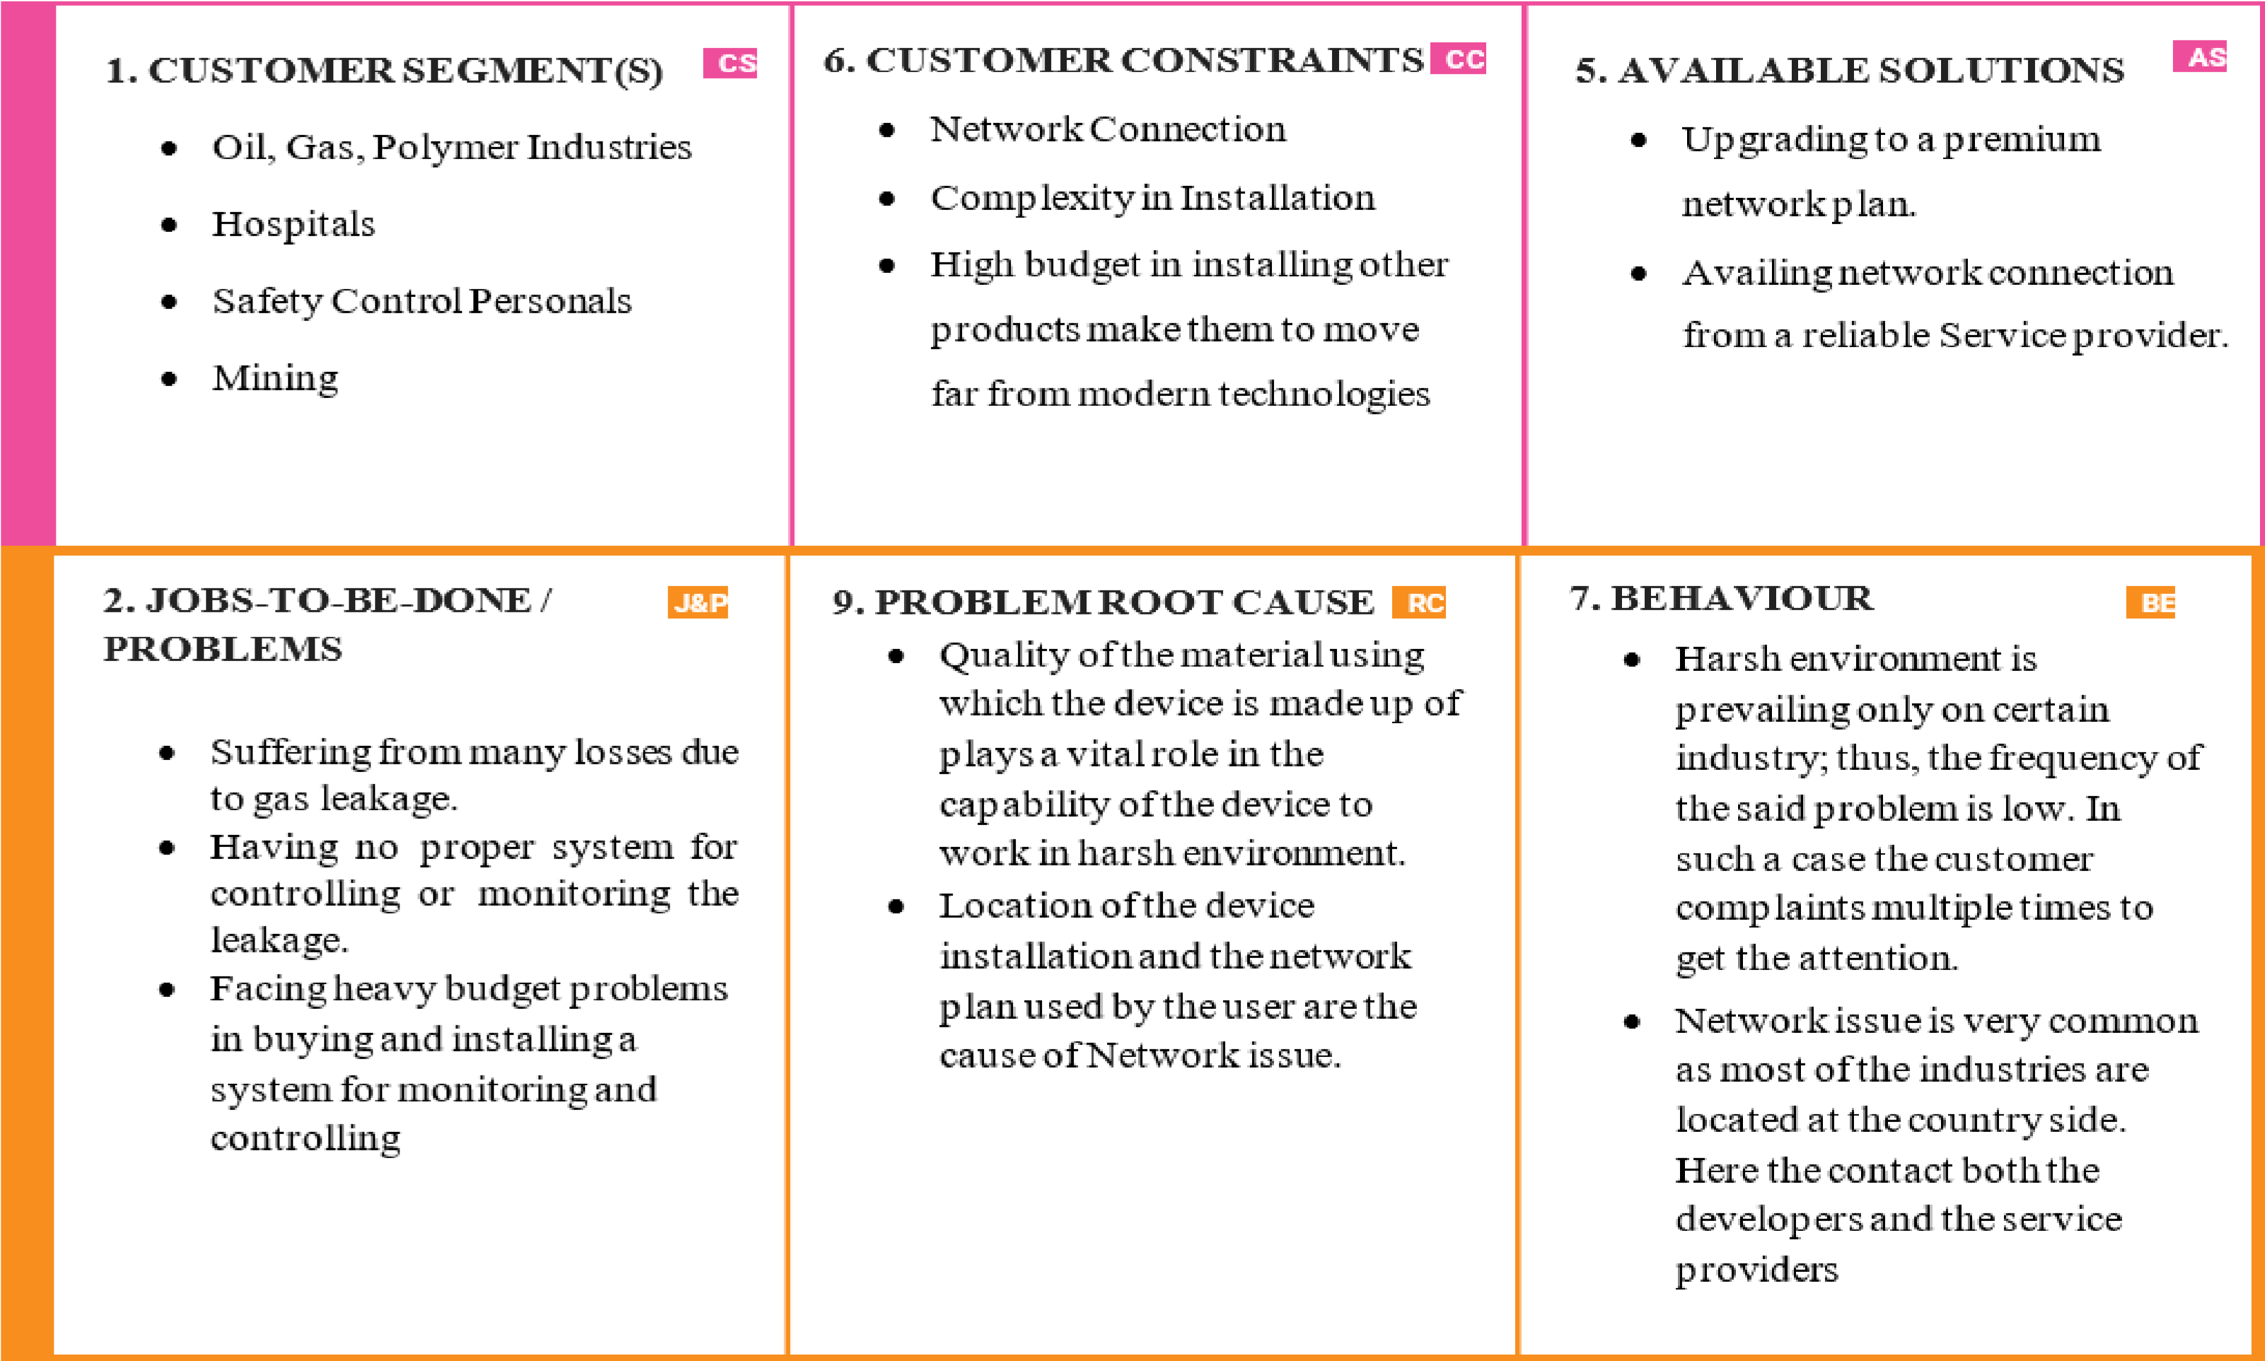

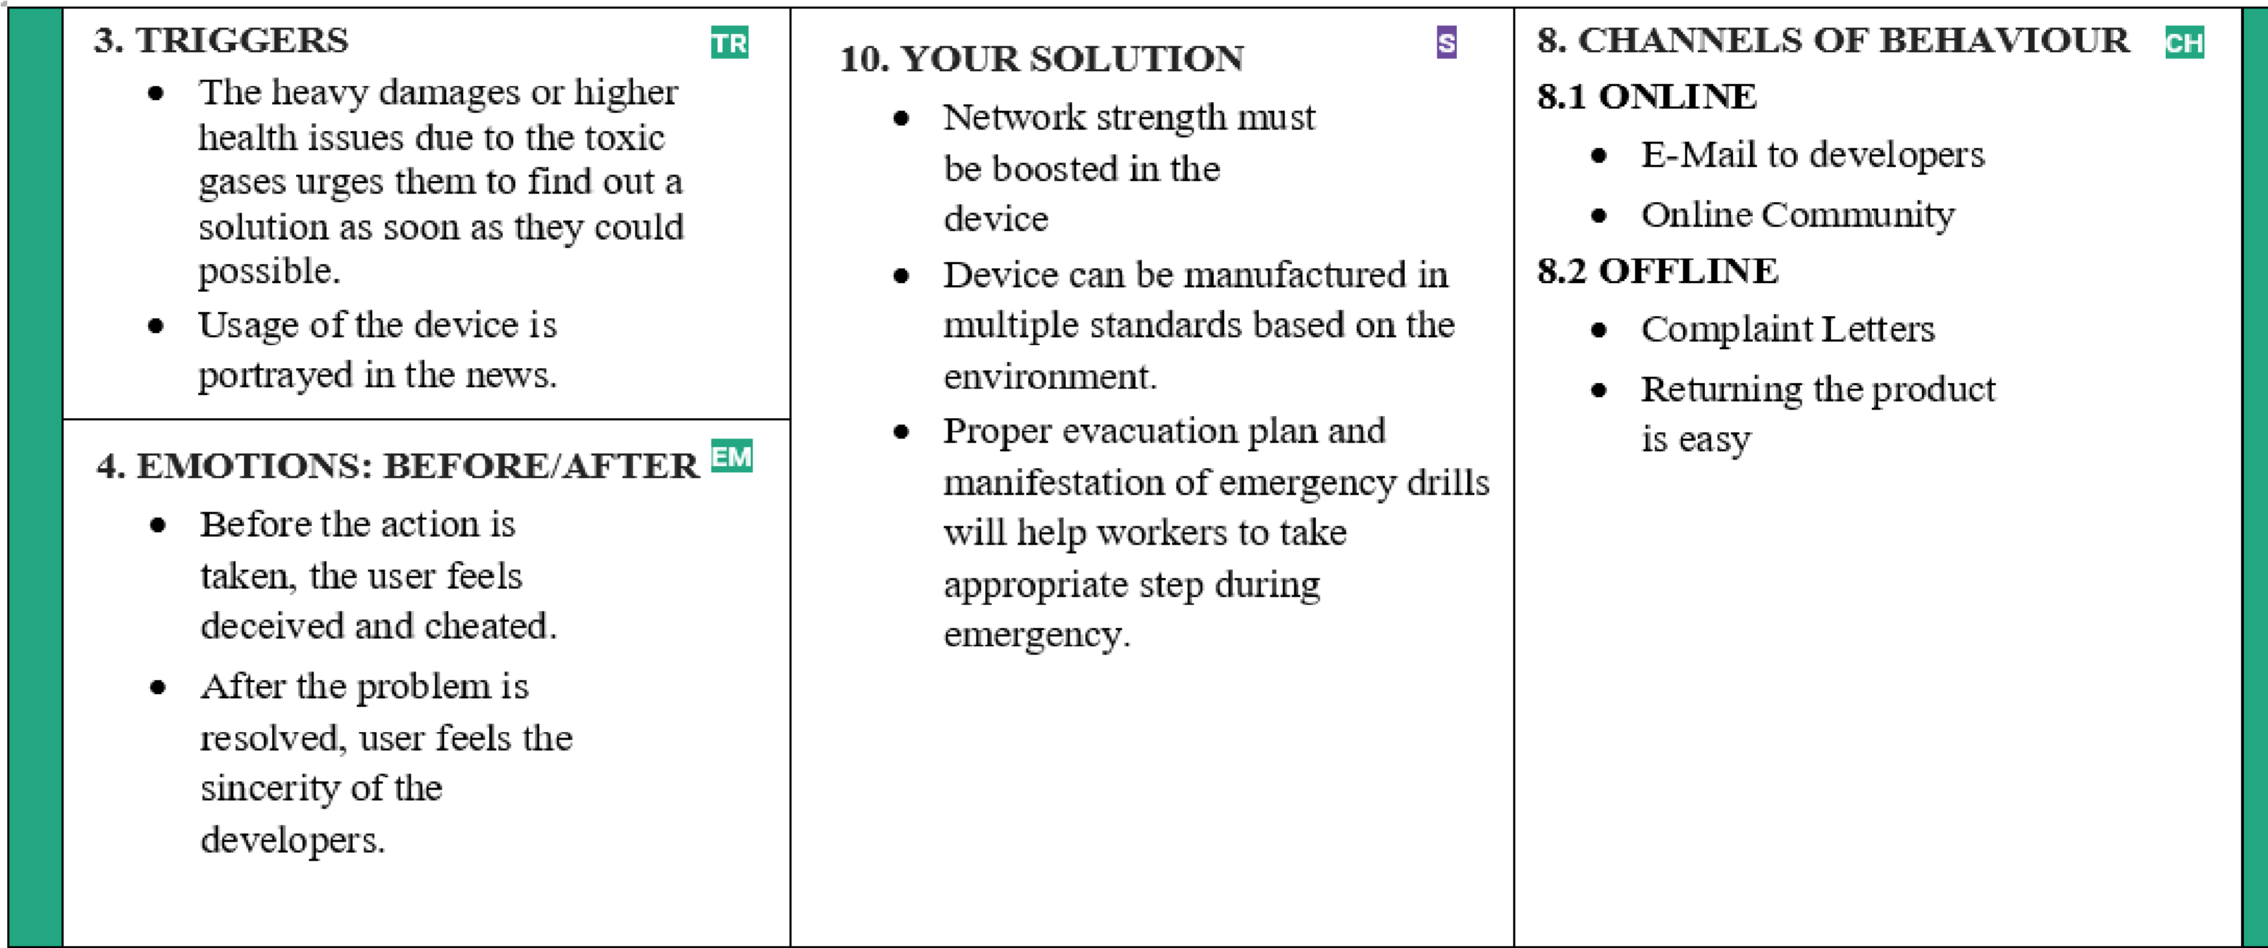

**F o c**